**PROGRAM No: 01DATE: 10-08-2022**

**AIM*:*** Design a Login Form with username and password using Linear Layout and toast valid credentials.

**Program co*de :***

**Activity.xml**

*<?*xml version="1.0" encoding="utf-8"*?>*<LinearLayout  
 xmlns:android="http://schemas.android.com/apk/res/android"  
 xmlns:app="http://schemas.android.com/apk/res-auto"  
 xmlns:tools="http://schemas.android.com/tools"  
 android:layout_width="match_parent"  
 android:layout_height="match_parent"  
 android:orientation="vertical"  
 tools:context=".MainActivity">  
  
 <TextView  
 android:layout_width="wrap_content"  
 android:layout_height="wrap_content"  
 android:text="LOGIN PAGE"  
 android:textSize="30dp" />  
 <EditText  
 android:layout_width="wrap_content"  
 android:layout_height="wrap_content"  
 android:hint="Enter ur username"  
 android:id="@+id/btn1"  
 android:layout_marginTop="10dp" />  
 <EditText  
 android:layout_width="wrap_content"  
 android:layout_height="wrap_content"  
 android:hint="Enter ur password"  
 android:layout_marginTop="10dp"  
 android:id="@+id/btn2"  
 android:inputType="textPassword" />  
 <Button  
 android:layout_width="wrap_content"  
 android:layout_height="wrap_content"  
 android:text="Login"  
 android:id="@+id/et1"  
 android:layout_marginLeft="150dp" />  
  
</LinearLayout>

**Mainactivity.xml**

package com.example.myapplication;  
import androidx.appcompat.app.AppCompatActivity;  
import android.os.Bundle;  
import android.view.View

import android.widget.Button;  
import android.widget.EditText;

import android.widget.Toast;  
public class MainActivity extends AppCompatActivity {  
  
 @Override  
 protected void onCreate(Bundle savedInstanceState) {  
 super.onCreate(savedInstanceState);  
 setContentView(R.layout.*activity_main*);  
 EditText bnt1=findViewById(R.id.*btn1*);  
 EditText bnt2=findViewById(R.id.*btn2*);  
 Button button=findViewById(R.id.*et1*);  
 button.setOnClickListener(new View.OnClickListener() {  
 @Override  
 public void onClick(View view) {  
 validate (bnt1.getText().toString(),bnt2.getText().toString());  
 }  
 private void validate(String us,String p)  
 {  
 if (us.equals("admin")&&p.equals("1234"))  
 {  
 Toast.*makeText*(getApplicationContext(),"successfull",Toast.*LENGTH_LONG*).show();  
 }  
 else  
 {  
 Toast.*makeText*(getApplicationContext(),"Unsuccessfull",Toast.*LENGTH_LONG*).show();  
 }  
 }  
 });

**Result** : Program complied successfully and output verified .

**OUTPUT**

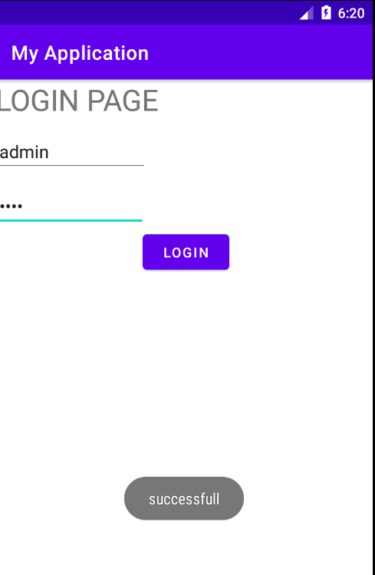

**PROGRAM No:0*2* Date:16-08-2022**

**AIM**: Write a program that demonstrate Activity Life cycle.

**Program Code:**

**Activity.xml**

*<?*xml version="1.0" encoding="utf-8"*?>*<androidx.constraintlayout.widget.ConstraintLayout xmlns:android="http://schemas.android.com/apk/res/android"  
 xmlns:app="http://schemas.android.com/apk/res-auto"  
 xmlns:tools="http://schemas.android.com/tools"  
 android:layout_width="match_parent"  
 android:layout_height="match_parent"  
 tools:context=".MainActivity">  
  
 <TextView  
 android:layout_width="wrap_content"  
 android:layout_height="wrap_content"  
 android:text="Hello World!"  
 app:layout_constraintBottom_toBottomOf="parent"  
 app:layout_constraintLeft_toLeftOf="parent"  
 app:layout_constraintRight_toRightOf="parent"  
 app:layout_constraintTop_toTopOf="parent" />  
  
</androidx.constraintlayout.widget.ConstraintLayout>

***Mainactivity.java***

package com.example.myapplication;  
  
import androidx.appcompat.app.AppCompatActivity;  
  
import android.os.Bundle;  
import android.util.Log;  
  
public class MainActivity extends AppCompatActivity {  
  
 @Override  
 protected void onCreate(Bundle savedInstanceState) {  
 super.onCreate(savedInstanceState);  
 setContentView(R.layout.*activity_main*);  
 Log.*d*("Lifecycle","onCreate invoked");  
 }  
 @Override  
 protected void onStart(){  
 super.onStart();  
 Log.*d*("Lifecycle","onStrat invoked");  
 }  
 @Override  
 protected void onResume(){  
 super.onResume();  
 Log.*d*("Lifecycle","onResume invoked");  
 }  
 @Override  
 protected void onPause(){  
 super.onPause();  
 Log.*d*("Lifecycle","onPause invoked");  
 }  
 @Override  
 protected void onStop(){  
 super.onStop();  
 Log.*d*("Lifecycle","onStop invoked");  
 }  
 @Override  
 protected void onRestart(){  
 super.onRestart();  
 Log.*d*("Lifecycle","onRestart invoked");  
 }  
 @Override  
 protected void onDestroy(){  
 super.onDestroy();  
 Log.*d*("Lifecycle","onDestroy invoked");  
 }  
}

**Result** : Program complied successfully and output verified .

**OUTPUT**

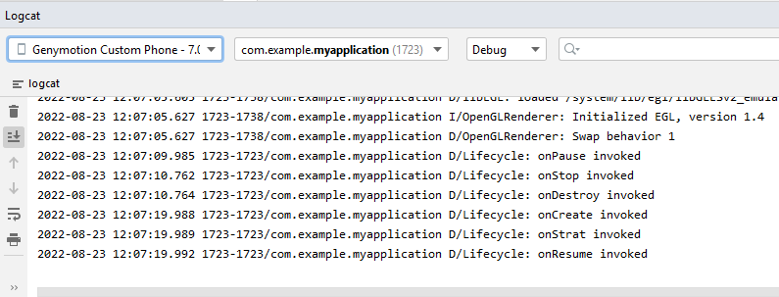

**PROGRAM No:03 Date:19-08-2022**

**AIM:** Implementing basic Arithmetic operation of a single calculator**.**

**Program Code:**

**Activity_main.xml**

*<?*xml version="1.0" encoding="utf-8"*?>*<LinearLayout xmlns:android="http://schemas.android.com/apk/res/android"  
 xmlns:app="http://schemas.android.com/apk/res-auto"  
 xmlns:tools="http://schemas.android.com/tools"  
 android:layout_width="match_parent"  
 android:layout_height="match_parent"  
 android:orientation="vertical"  
 tools:context=".MainActivity">  
  
 <TextView  
 android:layout_width="wrap_content"  
 android:layout_height="wrap_content"  
 android:text="Enter first number" />  
 <EditText  
 android:layout_width="match_parent"  
 android:layout_height="wrap_content"  
 android:id="@+id/text1"/>  
 <TextView  
 android:layout_width="wrap_content"  
 android:layout_height="wrap_content"  
 android:text="Enter second number"/>  
 <EditText  
 android:layout_width="wrap_content"  
 android:layout_height="wrap_content"  
 android:id="@+id/text2" />  
 <LinearLayout  
 android:layout_width="wrap_content"  
 android:layout_height="wrap_content" />  
 <Button  
 android:layout_width="wrap_content"  
 android:layout_height="wrap_content"  
 android:id="@+id/b1"  
 android:text="ADD" />  
 <Button  
 android:layout_width="wrap_content"  
 android:layout_height="wrap_content"  
 android:id="@+id/b2"  
 android:text="SUB"/></LinearLayout>

**Mainactivity.java**

package com.example.arithematic;  
  
import androidx.appcompat.app.AppCompatActivity;  
  
import android.os.Bundle;  
import android.widget.Button;  
import android.widget.EditText;  
import android.widget.TextView;  
  
  
public class MainActivity extends AppCompatActivity {  
 Button b,bb,bc,bd;  
 EditText et1,et2;  
 TextView tv1;  
  
 @Override  
 protected void onCreate(Bundle savedInstanceState) {  
 super.onCreate(savedInstanceState);  
 setContentView(R.layout.*activity_main*);  
 b=findViewById(R.id.*b1*);  
 bb=findViewById(R.id.*b2*);  
 bc=findViewById(R.id.*b3*);

bd=findViewById(R.id.*b4*);

et1=findViewById(R.id.*et1*);  
 et2=findViewById(R.id.*et2*);  
 tv1=findViewById(R.id.*tv1*);  
 b.setOnClickListener(new View.OnClickListener() {  
 @Override  
 public void onClick(View view) {  
 Double a1=Double.*parseDouble*(et1.getText().toString());  
 Double a2=Double.*parseDouble*(et2.getText().toString());  
 Double r=a1+a2;  
 tv1.setText("Result is="+String.*valueOf*(r));  
 }  
 });  
 bb.setOnClickListener(new View.OnClickListener() {  
 @Override  
 public void onClick(View view) {  
 Double a1=Double.*parseDouble*(et1.getText().toString());  
 Double a2=Double.*parseDouble*(et2.getText().toString());  
 Double r=a1-a2;  
 tv1.setText("Result is="+String.*valueOf*(r));  
 }  
 });  
 bc.setOnClickListener(new View.OnClickListener() {  
 @Override  
 public void onClick(View view) {  
 Double a1=Double.*parseDouble*(et1.getText().toString());  
 Double a2=Double.*parseDouble*(et2.getText().toString());  
 Double r=a1*a2;  
 tv1.setText("Result is="+String.*valueOf*(r));  
 }  
 });  
 bd.setOnClickListener(new View.OnClickListener() {  
 @Override  
 public void onClick(View view) {  
 Double a1=Double.*parseDouble*(et1.getText().toString());  
 Double a2=Double.*parseDouble*(et2.getText().toString());  
 Double r=a1/a2;  
 tv1.setText("Result is="+String.*valueOf*(r));  
 }  
 });

}  
}

**Result** : Program complied successfully and output verified .

**OUTPUT**

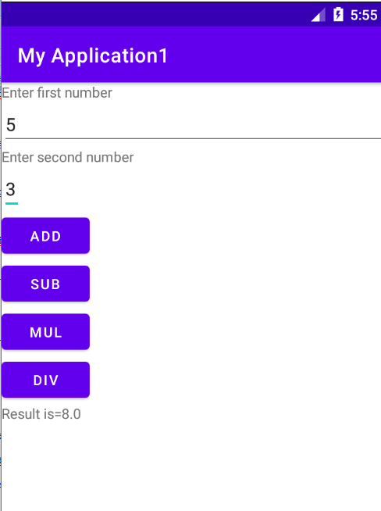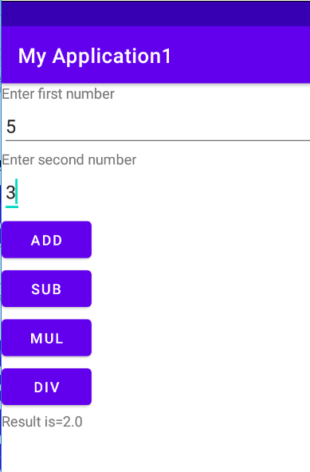

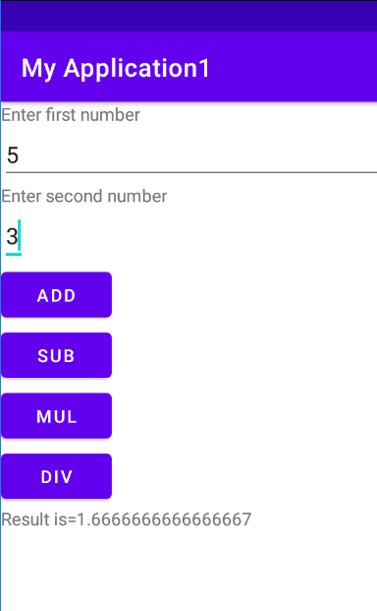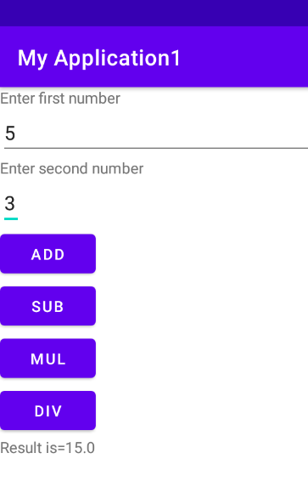

**PROGRAM NO:04 Date:23-08-2022**

**AIM:** Implement validation on various UI control.

**Program code:**

**Activity_main.xml:**

*<?*xml version="1.0" encoding="utf-8"*?>*<LinearLayout xmlns:android="http://schemas.android.com/apk/res/android"  
 xmlns:app="http://schemas.android.com/apk/res-auto"  
 xmlns:tools="http://schemas.android.com/tools"  
 android:layout_width="match_parent"  
 android:layout_height="match_parent"  
 android:orientation="vertical"  
 tools:context=".MainActivity">  
  
 <TextView  
 android:layout_width="wrap_content"  
 android:layout_height="wrap_content"  
 android:text="REGISTRATION"  
 android:textColor="@color/design_default_color_error"  
 android:textSize="30dp" />  
 <EditText  
 android:layout_width="wrap_content"  
 android:layout_height="wrap_content"  
 android:hint="Name"  
 android:id="@+id/name" />  
 <EditText  
 android:layout_width="wrap_content"  
 android:layout_height="wrap_content"  
 android:hint="Mobile No:"  
 android:id="@+id/mob" />  
 <EditText  
 android:layout_width="wrap_content"  
 android:layout_height="wrap_content"  
 android:hint="AGE"  
 android:id="@+id/age" />  
 <TextView  
 android:layout_width="wrap_content"  
 android:layout_height="wrap_content"  
 android:text="Gender"  
 android:textSize="20dp"  
 android:textColor="@color/black" />  
 <RadioGroup  
 android:layout_width="wrap_content"  
 android:layout_height="wrap_content"  
 android:id="@+id/rg" >  
 <RadioButton  
 android:layout_width="wrap_content"  
 android:layout_height="wrap_content"  
 android:id="@+id/b1"  
 android:text="Male" />  
 <RadioButton  
 android:layout_width="wrap_content"  
 android:layout_height="wrap_content"  
 android:id="@+id/b2"  
 android:text="Female" />  
 </RadioGroup>  
 <Button  
 android:layout_width="wrap_content"  
 android:layout_height="wrap_content"  
 android:text="SUBMIT"  
 android:id="@+id/button1" />  
 <CheckBox  
 android:layout_width="wrap_content"  
 android:layout_height="wrap_content"  
 android:text="I agree all terms and conditions"  
 android:id="@+id/checkbox" />

</LinearLayout>

**Main Activity.java**

package com.example.myapplication;  
  
import androidx.appcompat.app.AppCompatActivity;  
  
import android.content.Context;  
import android.content.Intent;  
import android.os.Bundle;  
import android.view.View;  
import android.widget.Button;  
import android.widget.CheckBox;  
import android.widget.EditText;  
import android.widget.RadioButton;  
import android.widget.RadioGroup;  
import android.widget.Toast;  
  
public class MainActivity extends AppCompatActivity {  
  
 EditText name;  
 EditText mobileno;  
 EditText age;  
 RadioGroup radioGroup;  
 RadioButton male;  
 RadioButton female;  
 CheckBox checkbox;  
 Button button;  
 @Override  
 protected void onCreate(Bundle savedInstanceState) {  
 super.onCreate(savedInstanceState);  
 setContentView(R.layout.*activity_main*);  
 name=findViewById(R.id.*name*);  
 mobileno=findViewById(R.id.*mob*);  
 age=findViewById(R.id.*age*);  
 radioGroup=findViewById(R.id.*rg*);  
 male=findViewById(R.id.*b1*);  
 female=findViewById(R.id.*b2*);  
 checkbox=findViewById(R.id.*checkbox*);  
 button=findViewById(R.id.*button1*);  
 button.setOnClickListener(new View.OnClickListener() {  
 @Override  
 public void onClick(View view) {  
 if (error()) {  
 Intent i=new Intent( MainActivity.this,login.class);  
 startActivity(i);  
 }  
 }  
 });  
 }  
 private boolean error(){  
 if(name.getText().toString().length()==0) {  
 Toast.*makeText*(getApplicationContext(), "please enter your name",Toast.*LENGTH_LONG*).show();  
 return false;  
 }  
 else if (mobileno.getText().toString().length()==0) {  
 Toast.*makeText*(getApplicationContext(), "please enter your mobile number",Toast.*LENGTH_LONG*).show();  
 return false;  
 }  
 else if (mobileno.getText().toString().length()!=10){  
 Toast.*makeText*(getApplicationContext(), "please enter your 10 digit number", Toast.*LENGTH_LONG*).show();  
 return false;  
 }  
 else if (! male.isChecked() && ! female.isChecked()) {  
 Toast.*makeText*(getApplicationContext(), "please enter your choose radio button", Toast.*LENGTH_LONG*).show();  
 return false;  
 }  
 else if (! checkbox.isChecked()) {  
 Toast.*makeText*(getApplicationContext(), "please click on checkbox", Toast.*LENGTH_LONG*).show();  
 return false;  
 }  
 else{  
 return true;  
 }  
 }  
  
}

**Activity_login.xml**

*<?*xml version="1.0" encoding="utf-8"*?>*<androidx.constraintlayout.widget.ConstraintLayout xmlns:android="http://schemas.android.com/apk/res/android"  
 xmlns:app="http://schemas.android.com/apk/res-auto"  
 xmlns:tools="http://schemas.android.com/tools"  
 android:layout_width="match_parent"  
 android:layout_height="match_parent"  
 tools:context=".login">  
  
 <TextView  
 android:id="@+id/textView"  
 android:layout_width="wrap_content"  
 android:layout_height="wrap_content"  
 android:text="Welcome to Login Page"  
 tools:layout_editor_absoluteX="187dp"  
 tools:layout_editor_absoluteY="66dp" />  
</androidx.constraintlayout.widget.ConstraintLayout>

**Login.java**

package com.example.myapplication;  
  
import androidx.appcompat.app.AppCompatActivity;  
  
import android.os.Bundle;  
  
public class login extends AppCompatActivity {  
  
 @Override  
 protected void onCreate(Bundle savedInstanceState) {  
 super.onCreate(savedInstanceState);  
 setContentView(R.layout.*activity_login*);  
 }  
}

**Result** : Program complied successfully and output verified .

**OUTPUT**

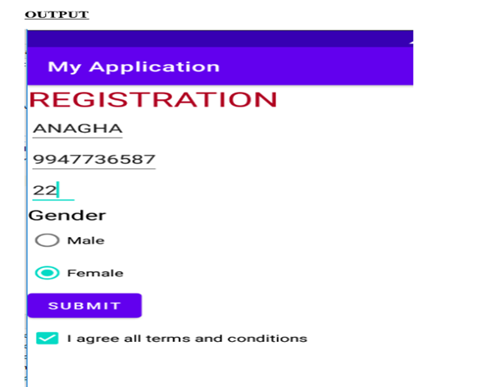

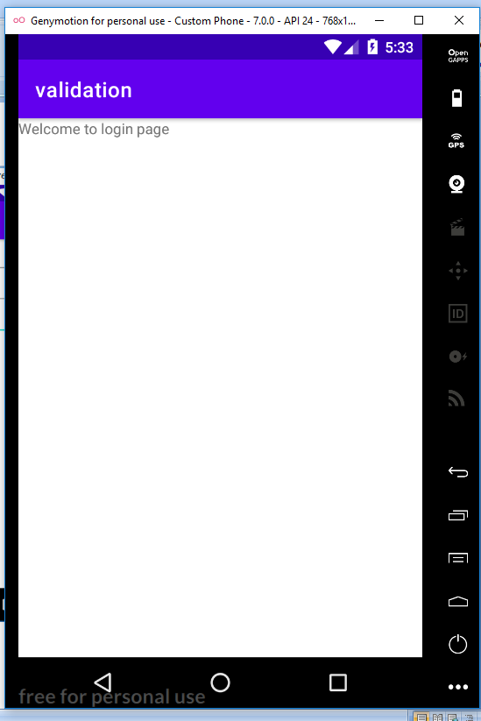

**PROGRAM NO:05 Date:26-08-2022**

**AIM:** Design a registration activity and store registration details in local memory of phone using intents and Shared Preferences.

**Program code:**

**Activity_main.xml:**

*<?*xml version="1.0" encoding="utf-8"*?>*<RelativeLayout xmlns:android="http://schemas.android.com/apk/res/android"  
 xmlns:app="http://schemas.android.com/apk/res-auto"  
 xmlns:tools="http://schemas.android.com/tools"  
 android:layout_width="match_parent"  
 android:layout_height="match_parent"  
 tools:context=".MainActivity"  
 tools:ignore="HardcodedText">  
 <TextView  
 android:id="@+id/textview"  
 android:layout_width="wrap_content"  
 android:layout_height="wrap_content"  
 android:layout_centerHorizontal="true"  
 android:layout_marginTop="32dp"  
 android:text="Registration form"  
 android:textColor="@android:color/black"  
 android:textSize="24sp"/>  
 <EditText  
 android:id="@+id/edit1"  
 android:layout_width="match_parent"  
 android:layout_height="wrap_content"  
 android:layout_below="@+id/textview"  
 android:layout_marginStart="16dp"  
 android:layout_marginTop="8dp"  
 android:layout_marginEnd="16dp"  
 android:hint="Enter your name"  
 android:padding="10dp"/>  
 <EditText  
 android:id="@+id/edit2"  
 android:layout_width="match_parent"  
 android:layout_height="wrap_content"  
 android:layout_below="@+id/edit1"  
 android:layout_marginStart="16dp"  
 android:layout_marginTop="8dp"  
 android:layout_marginEnd="16dp"  
 android:hint="Enter your age"  
 android:padding="10dp"  
 android:inputType="number"/>  
 <EditText  
 android:id="@+id/edit3"  
 android:layout_width="match_parent"  
 android:layout_height="wrap_content"  
 android:layout_below="@+id/edit2"  
 android:layout_marginStart="16dp"  
 android:layout_marginTop="8dp"  
 android:layout_marginEnd="16dp"  
 android:hint="Enter your Email id"  
 android:padding="10dp"/>  
 <EditText  
 android:id="@+id/edit4"  
 android:layout_width="match_parent"  
 android:layout_height="wrap_content"  
 android:layout_below="@+id/edit3"  
 android:layout_marginStart="16dp"  
 android:layout_marginTop="8dp"  
 android:layout_marginEnd="16dp"  
 android:hint="Enter your Address"  
 android:padding="10dp"/>  
 <EditText  
 android:id="@+id/edit5"  
 android:layout_width="match_parent"  
 android:layout_height="wrap_content"  
 android:layout_below="@+id/edit4"  
 android:layout_marginStart="16dp"  
 android:layout_marginTop="8dp"  
 android:layout_marginEnd="16dp"  
 android:hint="Enter your gender"  
 android:padding="10dp"/>  
 <EditText  
 android:id="@+id/edit6"  
 android:layout_width="match_parent"  
 android:layout_height="wrap_content"  
 android:layout_below="@+id/edit5"  
 android:layout_marginStart="16dp"  
 android:layout_marginTop="8dp"  
 android:layout_marginEnd="16dp"  
 android:hint="Enter your Qualification"  
 android:padding="10dp"/>  
 <Button  
 android:layout_width="wrap_content"  
 android:layout_height="wrap_content"  
 android:id="@+id/b1"  
 android:layout_below="@+id/edit6"  
 android:text="Submit"/>  
</RelativeLayout>

**Mainactivity.java**

package com.example.myapplication;  
  
import androidx.appcompat.app.AppCompatActivity;  
  
import android.os.Bundle;  
  
import androidx.appcompat.app.AppCompatActivity;  
import android.content.Intent;  
import android.content.SharedPreferences;  
import android.os.Bundle;  
import android.view.View;  
import android.widget.Button;  
import android.widget.EditText;  
public class MainActivity extends AppCompatActivity {  
 private EditText name,age,email,address,gender,quali;  
 Button b1;  
 @Override  
 protected void onCreate(Bundle savedInstanceState) {  
 super.onCreate(savedInstanceState);  
 setContentView(R.layout.*activity_main*);  
 name=findViewById(R.id.*edit1*);  
 age=findViewById(R.id.*edit2*);  
 email=findViewById(R.id.*edit3*);  
 address=findViewById(R.id.*edit4*);  
 gender=findViewById(R.id.*edit5*);  
 quali=findViewById(R.id.*edit6*);  
 b1=findViewById(R.id.*b1*);  
 b1.setOnClickListener(new View.OnClickListener() {  
 @Override  
 public void onClick(View view) {  
 Intent i=new Intent(MainActivity.this,MainActivity2.class);  
 startActivity(i);  
 }  
 });  
 }  
 protected void onResume() {  
 super.onResume();  
 SharedPreferences sh = getSharedPreferences("mysharedpref", *MODE_PRIVATE*);  
 String s1 = sh.getString("name", "");  
 int a = sh.getInt("age", 0);  
 String s2 = sh.getString("email", "");  
 String s3 = sh.getString("address", "");  
  
 String s4 = sh.getString("gender", "");  
 String s5 = sh.getString("quali", "");  
 name.setText(s1);  
 age.setText(String.*valueOf*(a));  
 email.setText(s2);  
 address.setText(s3);  
 gender.setText(s4);  
 quali.setText(s5);  
 }  
 protected void onPause() {  
 super.onPause();  
 SharedPreferences sharedPreferences = getSharedPreferences("mysharedpref",  
 *MODE_PRIVATE*);  
 SharedPreferences.Editor myEdit = sharedPreferences.edit();  
 myEdit.putString("name", name.getText().toString());  
 myEdit.putInt("age", Integer.*parseInt*(age.getText().toString()));  
 myEdit.putString("email", email.getText().toString());  
 myEdit.putString("address", address.getText().toString());  
 myEdit.putString("gender", gender.getText().toString());  
 myEdit.putString("quali", quali.getText().toString());  
 myEdit.commit();  
 }  
  
}

**Activity_main2.xml**

*<?*xml version="1.0" encoding="utf-8"*?>*<RelativeLayout xmlns:android="http://schemas.android.com/apk/res/android"  
 xmlns:app="http://schemas.android.com/apk/res-auto"  
 xmlns:tools="http://schemas.android.com/tools"  
 android:layout_width="match_parent"  
 android:layout_height="match_parent"  
 tools:context=".MainActivity2">  
 <TextView  
 android:layout_width="wrap_content"  
 android:layout_height="wrap_content"  
 android:text="Welocome"/>  
</RelativeLayout>

**Mainactivity2.java**

package com.example.myapplication;  
import androidx.appcompat.app.AppCompatActivity;  
import android.os.Bundle;  
public class MainActivity2 extends AppCompatActivity {  
  
 @Override  
 protected void onCreate(Bundle savedInstanceState) {  
 super.onCreate(savedInstanceState);  
 setContentView(R.layout.*activity_main2*);  
 }

**Result** : Program complied successfully and output verified .

**OUTPUT**

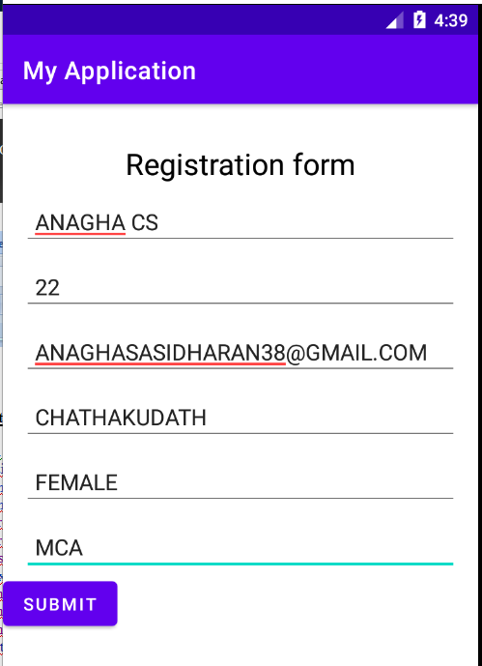

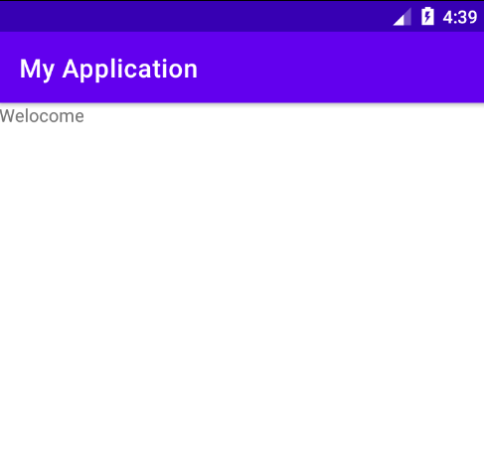

**PROGRAM No: 06 Date:30-08-2022**

**AIM:** Design a simple Calculator using Grid Layout and Cascaded Linear Layout.

**Program Code:**

**Activity.xml :**

*<?*xml version="1.0" encoding="utf-8"*?>*<GridLayout xmlns:android="http://schemas.android.com/apk/res/android"  
 xmlns:app="http://schemas.android.com/apk/res-auto"  
 xmlns:tools="http://schemas.android.com/tools"  
 android:layout_width="match_parent"  
 android:layout_height="match_parent"  
 tools:context=".MainActivity">  
  
 <TextView  
 android:layout_width="wrap_content"  
 android:layout_height="wrap_content"  
 android:text="Enter your first number"  
 android:layout_row="0"  
 android:layout_column="0" />  
 <EditText  
 android:layout_width="50dp"  
 android:layout_height="50dp"  
 android:id="@+id/n1"  
 android:layout_row="1"  
 android:layout_column="0"/>  
 <TextView  
 android:layout_width="wrap_content"  
 android:layout_height="wrap_content"  
 android:text="Enter your second number"  
 android:layout_row="2"  
 android:layout_column="0"/>  
 <EditText  
 android:layout_width="50dp"  
 android:layout_height="50dp"  
 android:id="@+id/n2"  
 android:layout_row="3"  
 android:layout_column="0" />  
 <LinearLayout  
 android:layout_width="wrap_content"  
 android:layout_height="wrap_content"  
 android:orientation="vertical">  
  
  
<Button  
 android:text="ADD"  
 android:layout_width="wrap_content"  
 android:layout_height="wrap_content"  
 android:layout_row="4"  
 android:layout_column="0"  
 android:textColor="@color/black"  
 android:background="@color/design_default_color_primary"  
 android:id="@+id/add"/>  
 <Button  
 android:text="MUL"  
 android:layout_width="wrap_content"  
 android:layout_height="wrap_content"  
 android:layout_row="4"  
 android:layout_column="1"  
 android:textColor="@color/black"  
 android:background="@color/design_default_color_primary"  
 android:id="@+id/mul"/>

<Button  
 android:text="SUB"  
 android:layout_width="wrap_content"  
 android:layout_height="wrap_content"  
 android:layout_row="4"  
 android:layout_column="2"  
 android:textColor="@color/black"  
 android:background="@color/design_default_color_primary"  
 android:id="@+id/sub"/>  
 <Button  
 android:text="DIV"  
 android:layout_width="wrap_content"  
 android:layout_height="wrap_content"  
 android:layout_row="4"  
 android:layout_column="3"  
 android:textColor="@color/black"  
 android:background="@color/design_default_color_primary"  
 android:id="@+id/div"/>  
 </LinearLayout>  
 <TextView  
 android:hint="RESULT"  
 android:layout_width="70dp"  
 android:layout_height="50dp"  
 android:layout_row="2"  
 android:layout_column="2"  
 android:id="@+id/result"  
 android:textColor="@color/design_default_color_secondary"/>  
  
</GridLayout>

**Mainactivity.java**

package com.example.myapplication1;  
  
import androidx.appcompat.app.AppCompatActivity;  
  
import android.os.Bundle;  
import android.view.View;  
import android.widget.Button;  
import android.widget.EditText;  
import android.widget.TextView;  
  
public class MainActivity extends AppCompatActivity {  
  
 @Override  
 protected void onCreate(Bundle savedInstanceState) {  
 super.onCreate(savedInstanceState);  
 setContentView(R.layout.*activity_main*);  
 final EditText a=findViewById(R.id.*n1*) ;  
 final EditText b=findViewById(R.id.*n2*);  
 Button add=findViewById(R.id.*add*);  
 Button sub=findViewById(R.id.*sub*);  
 Button mul=findViewById(R.id.*mul*);  
 Button div=findViewById(R.id.*div*);  
 final TextView result=findViewById(R.id.*result*);  
 add.setOnClickListener(new View.OnClickListener() {  
 @Override  
 public void onClick(View view) {  
 Double n1=Double.*parseDouble*(a.getText().toString());  
 Double n2=Double.*parseDouble*(b.getText().toString());  
 Double r=n1+n2;  
 result.setText(String.*valueOf*(r));  
 }  
 } );  
  
 sub.setOnClickListener(new View.OnClickListener() {  
 @Override  
 public void onClick(View view) {  
 Double n1=Double.*parseDouble*(a.getText().toString());  
 Double n2=Double.*parseDouble*(b.getText().toString());  
 Double r=n1-n2;  
 result.setText(String.*valueOf*(r));  
 }  
 });  
 mul.setOnClickListener(new View.OnClickListener() {  
 @Override  
 public void onClick(View view) {  
 Double n1=Double.*parseDouble*(a.getText().toString());  
 Double n2=Double.*parseDouble*(b.getText().toString());  
 Double r=n1*n2;  
 result.setText(String.*valueOf*(r));  
 }  
 });  
 div.setOnClickListener(new View.OnClickListener() {  
 @Override  
 public void onClick(View view) {  
 Double n1=Double.*parseDouble*(a.getText().toString());  
 Double n2=Double.*parseDouble*(b.getText().toString());  
 Double r=n1/n2;  
 result.setText(String.*valueOf*(r));  
 }  
 });  
} }

**Result** : Program complied successfully and output verified .

**OUTPUT :**

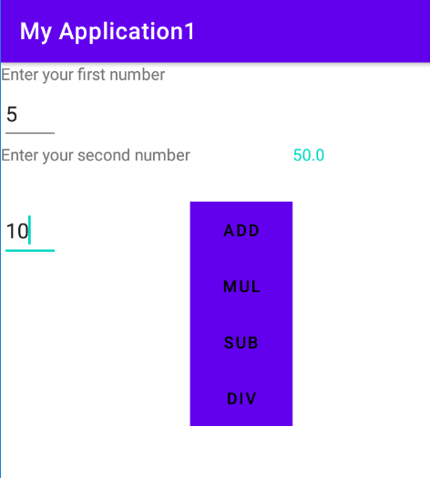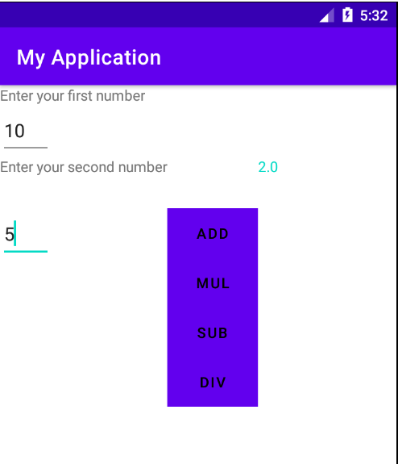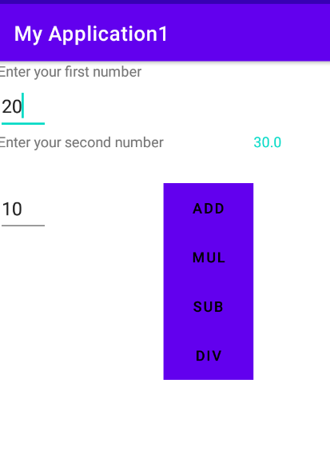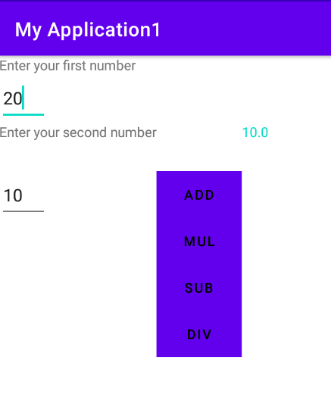

**PROGRAM No: 07 Date:02-09-2022**

**AIM:** Create a Facebook page using Relative Layout ; set properties using .xml file**.**

**Program Code:**

**Activity.xml :**

*<?*xml version="1.0" encoding="utf-8"*?>*<RelativeLayout  
 xmlns:android="http://schemas.android.com/apk/res/android"  
 xmlns:tools="http://schemas.android.com/tools"  
 android:id="@+id/activity_main"  
 android:layout_width="match_parent"  
 android:layout_height="match_parent"  
 tools:context=".MainActivity">  
  
 <RelativeLayout  
  
 android:id="@+id/relativelayout"  
 android:layout_width="match_parent"  
 android:layout_height="wrap_content">  
 <ImageView  
 android:layout_width="match_parent"  
 android:layout_height="250dp"  
 android:id="@+id/banner"  
 android:src="@drawable/images1"  
 android:scaleType="centerCrop"/>  
 <ImageView  
 android:layout_marginLeft="15dp"  
 android:layout_width="100dp"  
 android:layout_height="150dp"  
 android:id="@+id/profilepic"  
 android:src="@drawable/images2"  
 android:layout_alignBottom="@+id/linearLayout"/>

<LinearLayout  
 android:layout_toRightOf="@+id/profilepic"  
 android:layout_width="match_parent"  
 android:layout_height="wrap_content"  
 android:layout_below="@+id/banner"  
 android:orientation="horizontal"  
 android:weightSum="100"  
 android:id="@+id/linearLayout">  
 <Button  
 android:layout_width="wrap_content"  
 android:layout_height="wrap_content"  
 android:text="Timeline"  
 android:textSize="5dp"  
 android:layout_weight="10"/>

<Button  
 android:layout_weight="10"  
 android:textSize="5dp"  
 android:layout_width="wrap_content"  
 android:layout_height="wrap_content"  
 android:text="About"/>  
 <Button  
 android:layout_weight="10"  
 android:textSize="5dp"  
 android:layout_width="wrap_content"  
 android:layout_height="wrap_content"  
 android:text="Friends"/>  
 <Button  
 android:layout_weight="10"  
 android:textSize="5dp"  
 android:layout_width="wrap_content"  
 android:layout_height="wrap_content"  
 android:text="photos"/>  
 <Button  
 android:layout_weight="10"  
 android:textSize="5dp"  
 android:layout_width="wrap_content"  
 android:layout_height="wrap_content"  
 android:text="More"/>  
 </LinearLayout>

<EditText  
 android:textColor="@color/white"  
 android:textStyle="bold"  
 android:layout_width="wrap_content"  
 android:layout_height="wrap_content"  
 android:inputType="textPersonName"  
 android:text="Thasni"  
 android:ems="10"  
 android:layout_alignParentEnd="true"  
 android:layout_marginEnd="55dp"  
 android:id="@+id/textName"  
 android:layout_alignBottom="@+id/banner"/>

</RelativeLayout>

<RelativeLayout  
 android:paddingRight="15dp"  
 android:paddingLeft="15dp"  
 android:paddingTop="15dp"  
 android:paddingBottom="15dp"  
 android:layout_below="@+id/relativelayout"  
 android:layout_width="match_parent"  
 android:layout_height="wrap_content">

<LinearLayout  
 android:layout_width="match_parent"  
 android:layout_height="wrap_content"  
 android:orientation="horizontal"  
 android:id="@+id/linearLayout2">  
  
 <ImageView  
 android:layout_marginLeft="5dp"  
 android:layout_marginTop="15dp"  
 android:layout_width="25dp"  
 android:layout_height="25dp"  
 android:src="@drawable/images2"/>  
  
 <EditText  
 android:id="@+id/etPost"  
 android:layout_marginLeft="10dp"  
 android:textSize="15sp"  
 android:layout_width="match_parent"  
 android:layout_height="60dp"  
 android:hint="What's on your mind?"/>  
 </LinearLayout>  
 <Button  
 android:textSize="10sp"  
 android:text="Post"  
 android:layout_width="70dp"  
 android:layout_height="30dp"  
 android:layout_alignParentRight="true"  
 android:layout_below="@+id/linearLayout2"/>  
 </RelativeLayout>

**Mainactivity.java**

package com.example.myapplication1;  
  
import androidx.appcompat.app.AppCompatActivity;  
  
import android.os.Bundle;  
public class MainActivity extends AppCompatActivity {  
 @Override  
 protected void onCreate(Bundle savedInstanceState) {  
 super.onCreate(savedInstanceState);  
 setContentView(R.layout.*activity_main*);  
 }  
}

**Result** : Program complied successfully and output verified .

**OUTPUT :**

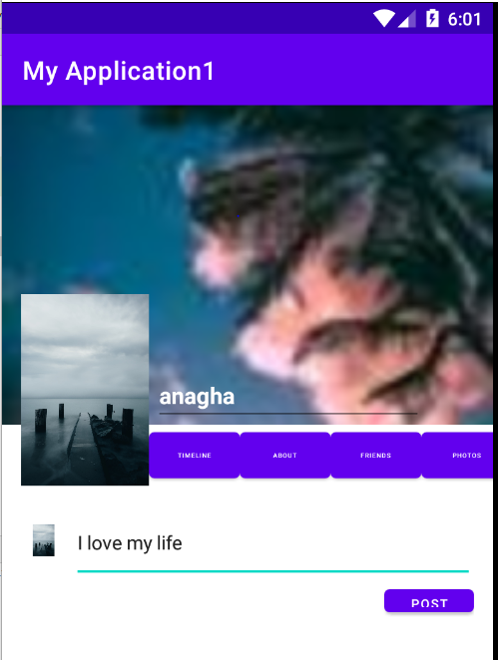

**PROGRAM No: 08 Date:14-09-2022**

**AIM:** Develop an application that toggle image using frame Layout**.**

**Program Code:**

**Activity.xml :**

<FrameLayout xmlns:android="http://schemas.android.com/apk/res/android"  
 android:id="@+id/frameLayout"  
 android:layout_width="fill_parent"  
 android:layout_height="fill_parent">  
 <ImageView  
 android:id="@+id/image1"  
 android:layout_width="match_parent"  
 android:layout_height="239dp"  
 android:scaleType="centerCrop"  
 android:src="@drawable/images1" />*<!--Change image as per your name of image saved in drawable-->* <ImageView  
 android:id="@+id/image2"  
 android:layout_width="match_parent"  
 android:layout_height="239dp"  
 android:scaleType="centerCrop"  
 android:src="@drawable/image2" />  
</FrameLayout>

**Mainactivity.java**

package com.example.myapplication;  
  
import androidx.appcompat.app.AppCompatActivity;  
import android.os.Bundle;  
import android.view.View;  
import android.widget.ImageView;  
public class MainActivity extends AppCompatActivity {  
 ImageView i1,i2;  
 @Override  
 protected void onCreate(Bundle savedInstanceState) {  
 super.onCreate(savedInstanceState);  
 setContentView(R.layout.*activity_main*);  
 i1=findViewById(R.id.*image1*);  
 i2=findViewById(R.id.*image2*);  
 i2.setOnClickListener(new View.OnClickListener() {  
 @Override  
 public void onClick(View view) {  
 i2.setVisibility(View.*GONE*);  
 i1.setVisibility(View.*VISIBLE*);  
  
 }  
 });  
 i1.setOnClickListener(new View.OnClickListener() {  
 @Override  
 public void onClick(View view) {  
 i1.setVisibility(View.*GONE*);  
 i2.setVisibility(View.*VISIBLE*);  
  
 }  
 });  
 }  
  
  
}

**Result** : Program complied successfully and output verified .

**OUTPUT :**

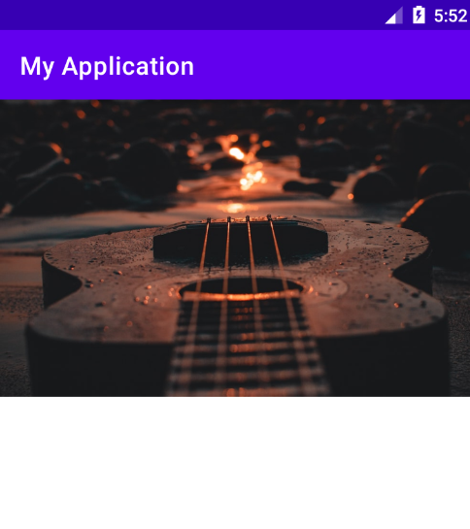

**PROGRAM No:09 Date:16-09-2022**

**AIM:** Develop application that works with Implicit intents .

**Program Code:**

**Activity.xml :**

*<?*xml version="1.0" encoding="utf-8"*?>*<LinearLayout xmlns:android="http://schemas.android.com/apk/res/android"  
 xmlns:app="http://schemas.android.com/apk/res-auto"  
 xmlns:tools="http://schemas.android.com/tools"  
 android:layout_width="match_parent"  
 android:layout_height="match_parent"  
 tools:context=".MainActivity">  
 <EditText  
 android:id="@+id/t1"  
 android:layout_width="wrap_content"  
 android:layout_height="wrap_content"  
 android:text="http://www.google.co.in" />  
 <Button  
 android:id="@+id/btn1"  
 android:layout_width="wrap_content"  
 android:layout_height="wrap_content"  
 android:text="click" />  
</LinearLayout>

**Mainactivity.java**

package com.example.myapplication;  
import androidx.appcompat.app.AppCompatActivity;  
import android.content.Intent;  
import android.net.Uri;  
import android.os.Bundle;  
import android.view.View;  
import android.widget.Button;  
import android.widget.EditText;  
public class MainActivity extends AppCompatActivity {  
 EditText et1;  
 Button b1;  
  
  
 @Override  
 protected void onCreate(Bundle savedInstanceState) {  
 super.onCreate(savedInstanceState);  
 setContentView(R.layout.*activity_main*);  
 et1=findViewById(R.id.*t1*);  
 b1=findViewById(R.id.*btn1*);  
 b1.setOnClickListener(new View.OnClickListener() {  
 @Override  
 public void onClick(View view) {  
 String url=et1.getText().toString();  
 Intent i=new Intent(Intent.*ACTION_VIEW*, Uri.*parse*(url));  
 startActivity(i);  
 }  
 });  
 }  
}

**Result** : Program complied successfully and output verified .

**OUTPUT**

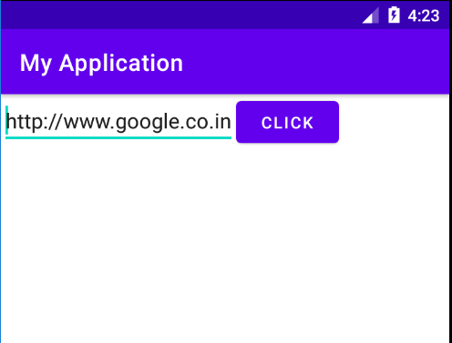

**PROGRAM NO:10 Date:20-09-2022**

**AIM:** Implement option Menu to navigate to activities**.**

**Program code:**

**Activitymain.xml:**

*<?*xml version="1.0" encoding="utf-8"*?>*<androidx.constraintlayout.widget.ConstraintLayout xmlns:android="http://schemas.android.com/apk/res/android"  
 xmlns:app="http://schemas.android.com/apk/res-auto"  
 xmlns:tools="http://schemas.android.com/tools"  
 android:layout_width="match_parent"  
 android:layout_height="match_parent"  
 tools:context=".MainActivity">  
  
 <TextView  
 android:layout_width="wrap_content"  
 android:layout_height="wrap_content"  
 android:text="Hello World!"  
 app:layout_constraintBottom_toBottomOf="parent"  
 app:layout_constraintLeft_toLeftOf="parent"  
 app:layout_constraintRight_toRightOf="parent"  
 app:layout_constraintTop_toTopOf="parent" />  
  
</androidx.constraintlayout.widget.ConstraintLayout>

**Mainactivity.java**

package com.example.myapplication;  
  
import androidx.annotation.NonNull;  
import androidx.appcompat.app.AppCompatActivity;  
  
import android.os.Bundle;  
import android.view.Menu;  
import android.view.MenuItem;  
import android.widget.Toast;  
  
import com.example.myapplication.R;  
  
public class MainActivity extends AppCompatActivity {  
  
 @Override  
 protected void onCreate(Bundle savedInstanceState) {  
 super.onCreate(savedInstanceState);  
 setContentView(R.layout.*activity_main*);  
 }  
  
 @Override  
 public boolean onCreateOptionsMenu(Menu menu) {  
 getMenuInflater().inflate(R.menu.*menu*,menu);  
 return true;  
 }  
  
 @Override  
 public boolean onOptionsItemSelected(@NonNull MenuItem item) {  
 switch(item.getItemId()){  
 case R.id.*item1*:  
 Toast.*makeText*(getApplicationContext(),"File Selected", Toast.*LENGTH_SHORT*).show();  
 break;  
 case R.id.*item2*:  
 Toast.*makeText*(getApplicationContext(),"Edit Selected", Toast.*LENGTH_SHORT*).show();  
 break;  
  
 case R.id.*sitem1*:  
 Toast.*makeText*(getApplicationContext(),"Cut Selected", Toast.*LENGTH_SHORT*).show();  
 break;  
 case R.id.*sitem2*:  
 Toast.*makeText*(getApplicationContext(),"Copy Selected", Toast.*LENGTH_SHORT*).show();  
 break;  
 case R.id.*sitem3*:  
 Toast.*makeText*(getApplicationContext(),"Paste Selected", Toast.*LENGTH_SHORT*).show();  
 break;  
 case R.id.*item3*:  
 Toast.*makeText*(getApplicationContext(),"View Selected", Toast.*LENGTH_SHORT*).show();  
 break;  
  
 }  
 return super.onOptionsItemSelected(item);  
 }  
}

**Menu.xml**

*<?*xml version="1.0" encoding="utf-8"*?>*<menu xmlns:android="http://schemas.android.com/apk/res/android">  
 <item android:id="@+id/item1"  
 android:title="FILE"/>  
 <item android:id="@+id/item2"  
 android:title="EDIT">  
 <menu>  
 <item android:id="@+id/sitem1"  
 android:title="CUT"/>  
 <item android:id="@+id/sitem2"  
 android:title="COPY"/>  
 <item android:id="@+id/sitem3"  
 android:title="PASTE"/>  
 </menu>  
 </item>  
 <item android:id="@+id/item3"  
 android:title="VIEW"/>  
  
</menu>

**Result** : Program complied successfully and output verified .

**OUTPUT**

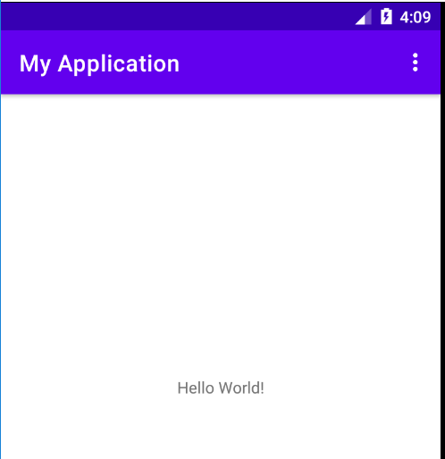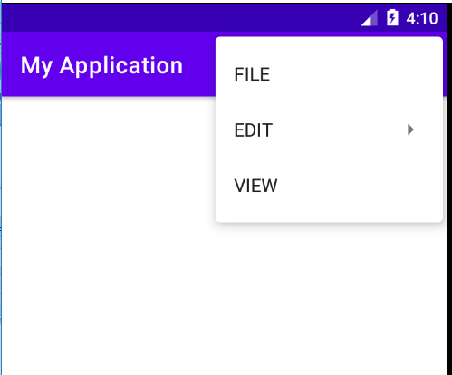

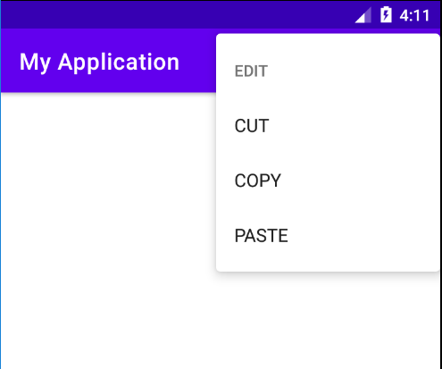

**PROGRAM No: 11 Date:27-09-2022**

**AIM:** Develop an application that users Array Adapter with List View .

**Program Code:**

**Activity.xml :**

*<?*xml version="1.0" encoding="utf-8"*?>*<RelativeLayout xmlns:android="http://schemas.android.com/apk/res/android"  
  
 xmlns:tools="http://schemas.android.com/tools"  
 android:layout_width="match_parent"  
 android:layout_height="match_parent"  
 tools:context=".MainActivity">  
  
 <ListView  
 android:layout_width="wrap_content"  
 android:layout_height="wrap_content"  
 android:id="@+id/lv1" />  
</RelativeLayout>

**MainActivity.java**

package com.example.myapplication10;  
  
import androidx.appcompat.app.AppCompatActivity;  
  
import android.content.Intent;  
import android.os.Bundle;  
import android.view.View;  
import android.widget.Adapter;  
import android.widget.AdapterView;  
import android.widget.ArrayAdapter;  
import android.widget.ListView;  
  
public class MainActivity extends AppCompatActivity {  
 ListView l;  
 String [] p={"Rajendra Prasad(1884-1963)","Radhakrishnan(1888-1993)","Zakir Husain(1894-1980)"};  
  
 @Override  
 protected void onCreate(Bundle savedInstanceState) {  
 super.onCreate(savedInstanceState);  
 setContentView(R.layout.*activity_main*);  
 l=(ListView)findViewById(R.id.*lv1*);  
 ArrayAdapter <String> adapter=new ArrayAdapter<String>(this, android.R.layout.*simple_list_item_1*,p);  
 l.setAdapter(adapter);  
 l.setOnItemClickListener(new AdapterView.OnItemClickListener() {  
 @Override  
 public void onItemClick(AdapterView<?> adapterView, View view, int i, long l) {  
 if(i==0){  
 startActivity(new Intent(MainActivity.this,MainActivity2.class));  
 }  
 else if(i==1){  
 startActivity(new Intent(MainActivity.this,MainActivity2.class));  
 }  
 }  
 });  
 }  
}

**Result** : Program complied successfully and output verified .

**OUTPUT**

